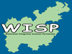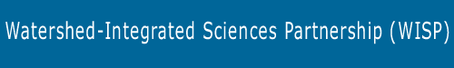
The Watershed Integrated Science Partnership (WISP) between the University of Massachusetts Boston and Three Local School Districts
The WISP Program is a National Science Foundation funded grant that supports fellowships and associated training that enable graduate students and advanced undergraduates in science to serve in K-12 schools (Boston, Dedham, Milton) as resources knowledgeable about both the content and applications of these disciplines.
Goals of the WISP Program
- Create an active interest and increased knowledge in Middle School students in Environmental Science (and Science in general) using the context of their local watershed, the Neponset River Watershed.
- Increase Teachers' science content knowledge.
- Develop within Science Graduate Students the interest, skills, and commitment to be actively engaged in K-12 education throughout their scientific careers.
- Develop connections between the University of Massachusetts Boston and a diverse set of school districts (housing a diverse population of students) located within a natural geographical boundary, the Neponset River Watershed.
- Evaluate the effectiveness of context learning for Middle School students and disseminate pedagogical research results through publication and national workshops.
Objectives of the WISP Program
- Increase working science knowledge in Middle School students: Math, Chemistry, Biology, Physics, Earth Science
- Stimulate Watershed educational activities.
- Recruit more Middle School students into science careers.
- Create lifelong connections and experiences for graduate students with K-12 education.
- Train Teachers with specific knowledge, especially Environmental Science examples to teach state and national frameworks and work with Science Curriculum Coordinators and Fellows to develop/modify curriculum.
- Develop personal working relationships between University Science faculty, College of Education faculty, and Administrators and School District Teachers, Science Curriculum Coordinators, Principals and Superintendents.
- Create interest and increase content knowledge of non-participating science and math teachers in participating Middle Schools.
- Disseminate results of this experimental program.
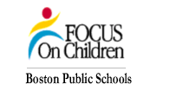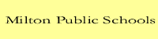
Please visit our website www.wisp.umb.edu for more information

